# ETE Reman User Guide

### How to register new company?

1. Open Admin Panel - http://Your Domain Name/index.php/admin/;

2. Enter your Name and Password:

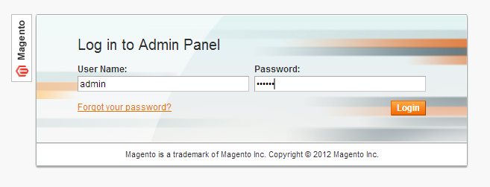

3. Open "Manage Companies" menu:

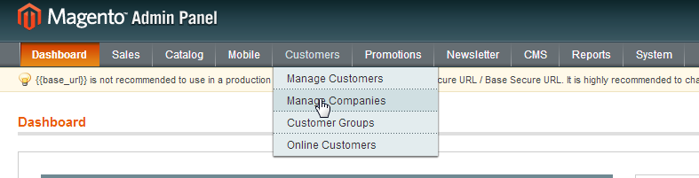

4. On that page you can edit already available companies and create new ones.

In order to create new company press on "Add Company" button in the right top corner:

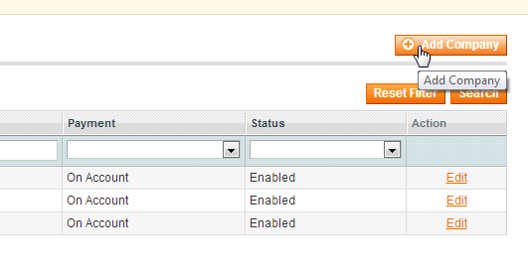

5. Fill in all necessary fields for General, Address and Warranty groups of attributes:

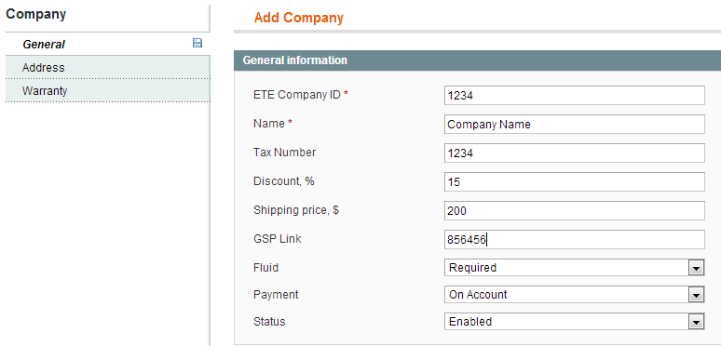

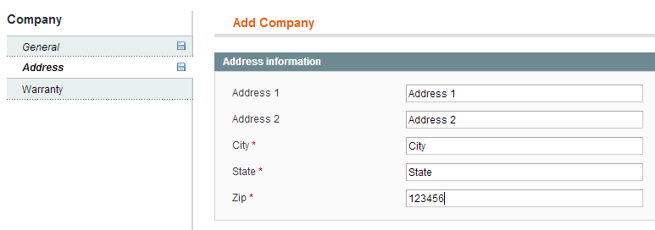

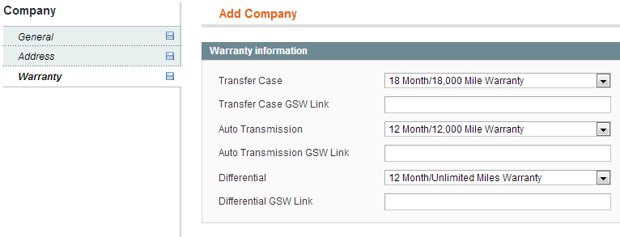

6. Press "Save Company" button in the top right corner to save data:



When it is done you will be redirected to list of companies where you can add another company or edit existing one.

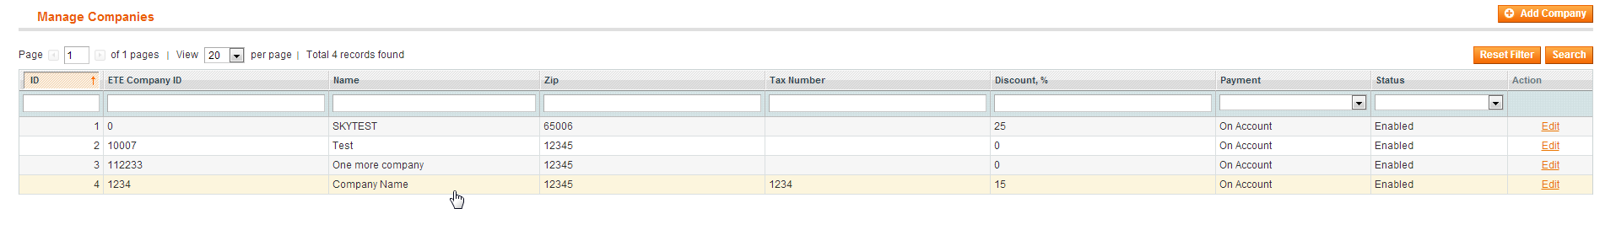

### Create New Customer User

1. Open Admin Panel - http://Your Domain Name/index.php/admin/;

2. Enter your Name and Password:



3. Open "Manage Customers" menu:

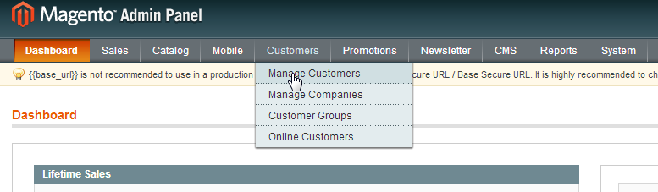

4.On that page you can edit already available customers and create new ones.

In order to create new company press on "Add New Customer" button in the right top corner:

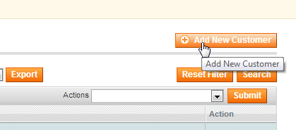

5. Fill in all necessary fields for Account Information:

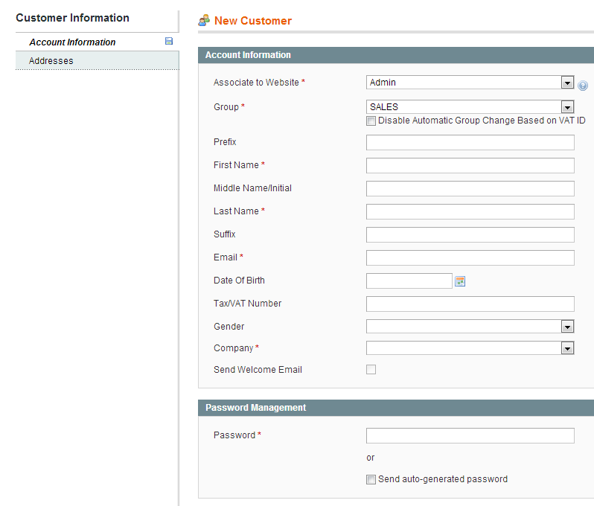

Fields Explanation:

1. **Associate to Website:** Main Website should be selected in order to assign new user to Ete Reman catalog site not to Admin



**2. Group:** New Customer Roles could be assigned here - SALES - have full access to Online Quotes; ADMIN -have full access to Online Quotes and can create new under his company account;

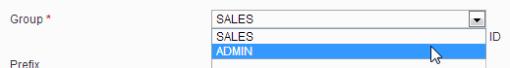

**3. Company:** Connect New User to Company profile in order to assign all Companies features for this user. So select necessary Company name from drop box;

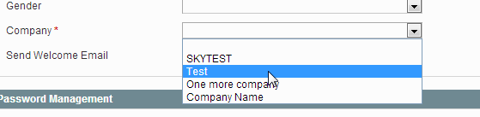

1. **Send Welcome Email:** If necessary check the select box (Optional)



1. **Password Management:** Assign new password for user or check the auto-generated password select box.

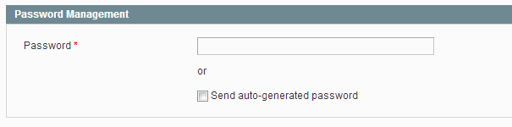

1. Press "Save Customer Button" in the right top corner to save data:



When it is done you will be redirected to list of customers (users) where you can add another customer or edit existing one.

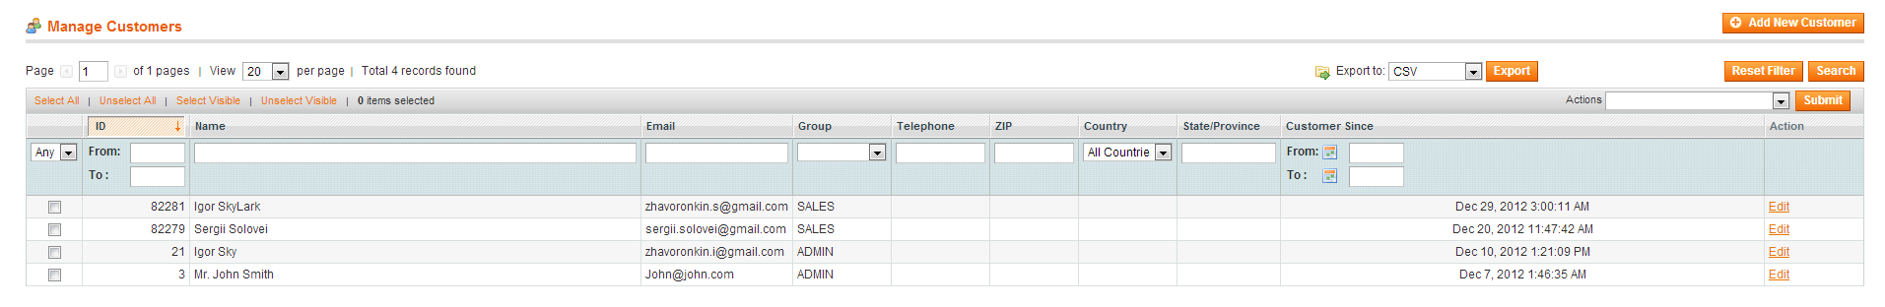

**Company registration request**

1. Open ETE Reman Online Quote Site and click on register link:

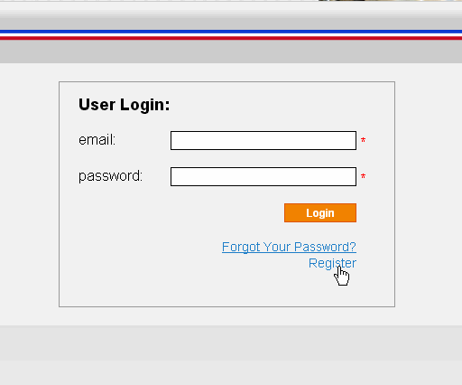

1. In the Company Registration Request page you should fill all required fields as shown below and click on Submit button:

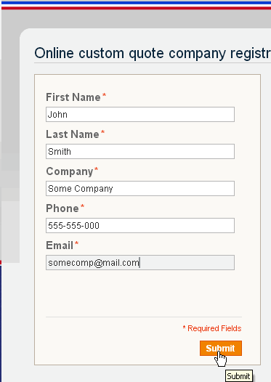

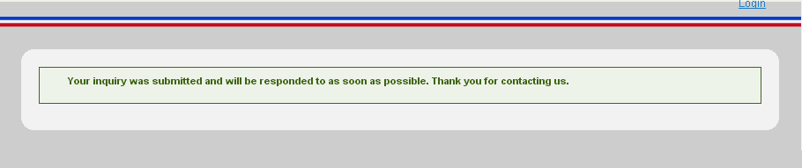

1. When Company Registration Form submitted by new customer, ETE Reman Admin will receive notification via admin Email.

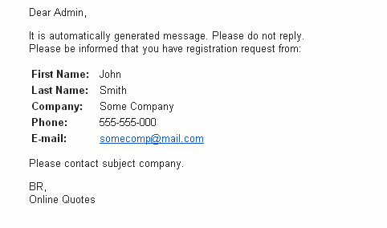

1. Then ETE Reman Admin should fill all necessary information about new Company according to “Register New Company” steps as it was mentioned above.